Employing Blockchain in Agriculture
In this project we are migrating agriculture crop sale details to Blockchain technologies as centralized servers can data can be altered or attack as this centralized maintain data in single server and if this server crash, hack then all services will be disturbed. Any employee maintaining server can alter database data on server.
To overcome from above issue we are migrating it to Blockchain technology where all data is stored at multiple nodes or servers in the form of block/transaction and associate each block with unique hash code and before storing new block Blockchain will verify hash code in each block and server and if any node data alter then its hash code verification will be failed and attack can be detected and due to this reason Blockchain data is called as immutable (cannot alter data by unauthorised users).
In this project we are designing Blockchain based online application for FARMERS, Distributors and Miller. Farmers can signup with the application and then login and after login can upload crop details, view orders from distributors or millers and can view fertilizers or pesticides details.
Distributors/Retailers/Consumer: This user can also signup, login and can view crop details and can purchase those crops
Miller: Can signup, login and purchase crop from farmer and sale to consumer.
All above transaction data will be saved in Blockchain.
In below screen you can see code to store data in Blockchain and verification will be done as POW (proof of work). In below screen shots read red colour comments to understand Blockchain code
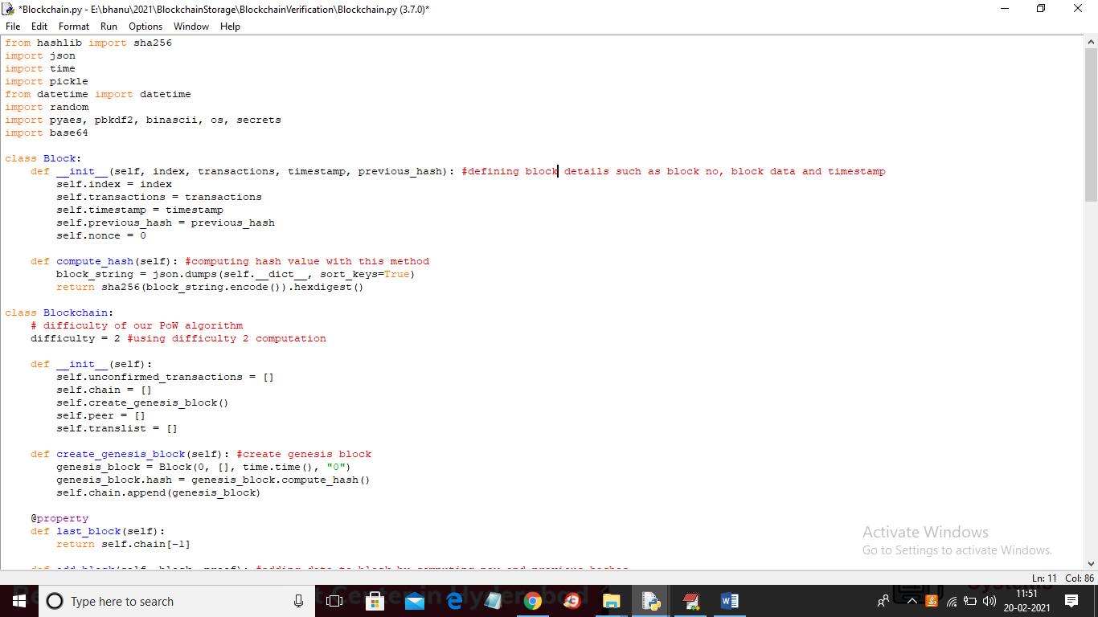
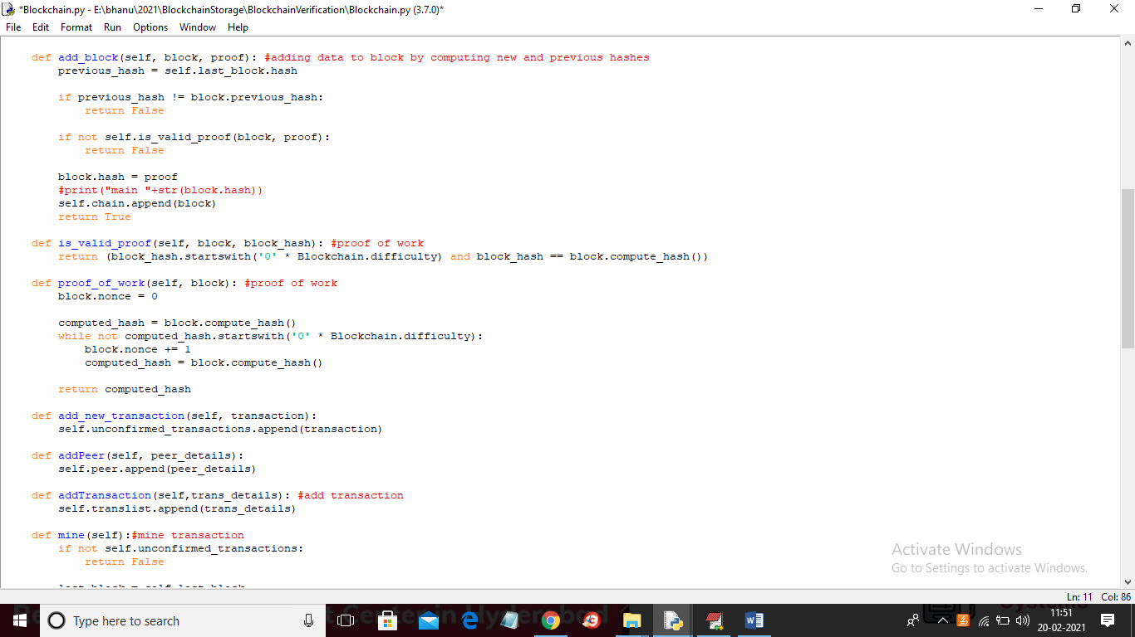
SCREEN
To run project double click on ‘run.bat’ file to start DJango Server and to get below screen
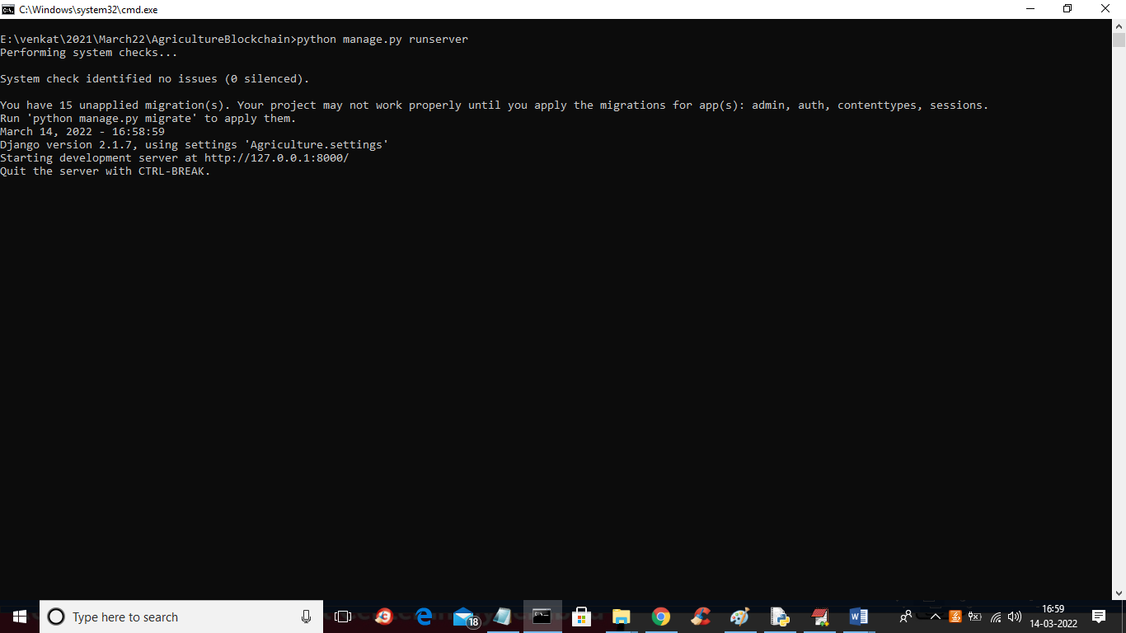
In above screen server started and now open browser and enter URL as ‘http://127.0.0.1:8000/index.htm’ and press enter key to get below screen
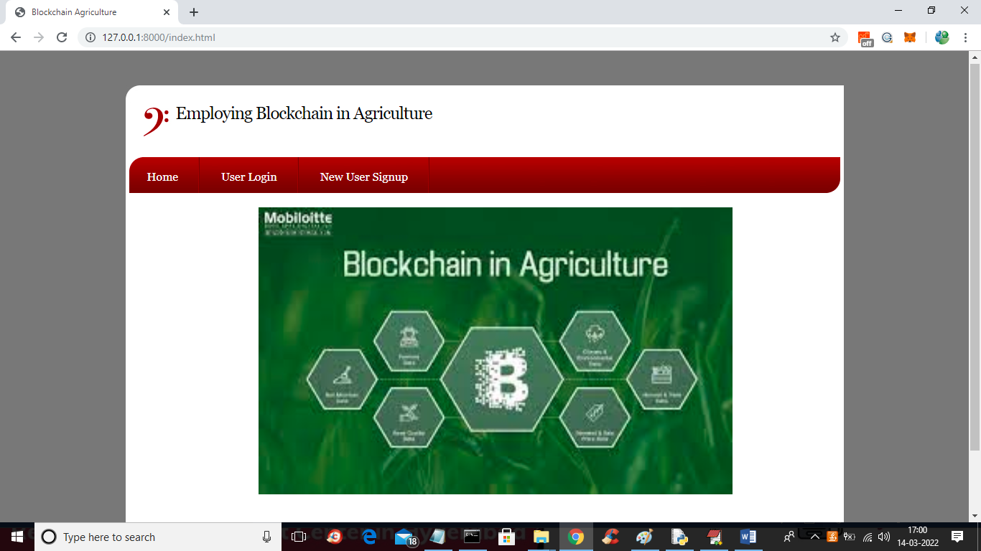
In above screen click on ‘New User Signup’ link to get below screen
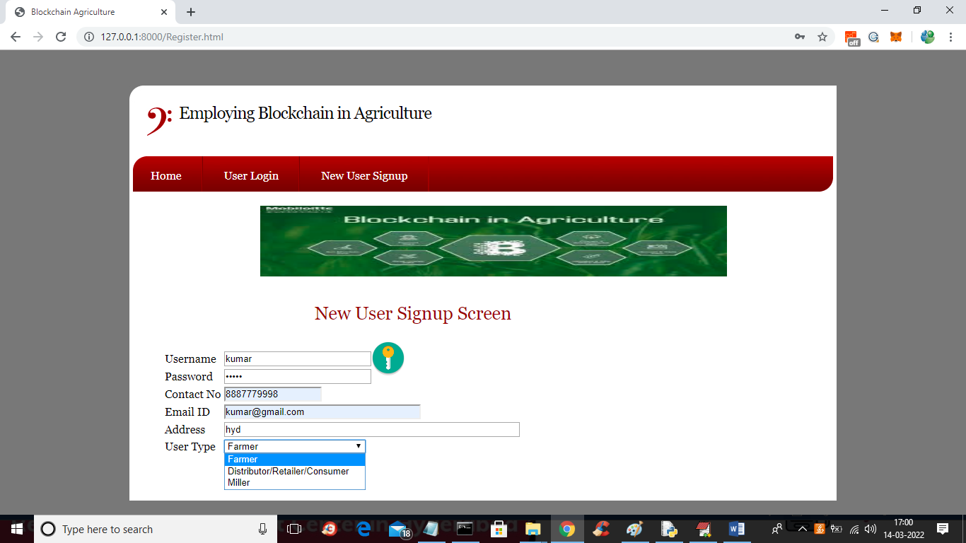
In above screen user is signup and select desire user as Farmer or distributor or Miller and then press submit button to get below output
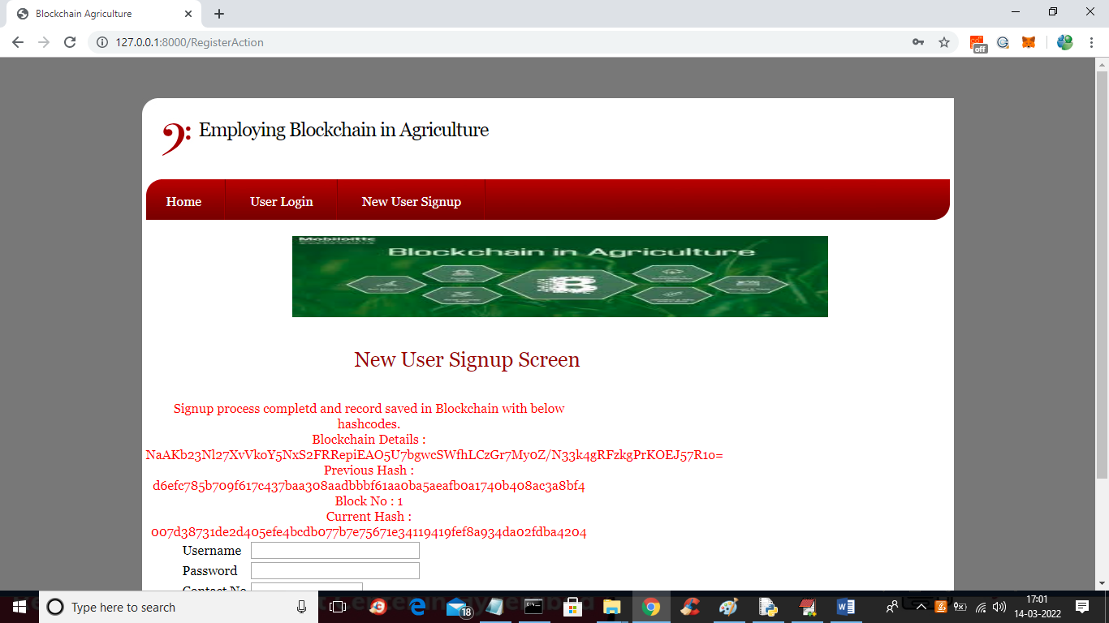
In above screen in red colour text we can see data is stored in Blockchain and we see hash code of previous and new blocks and similarly you can add distributor and miller user. Now click on ‘User Login’ link to get below screen
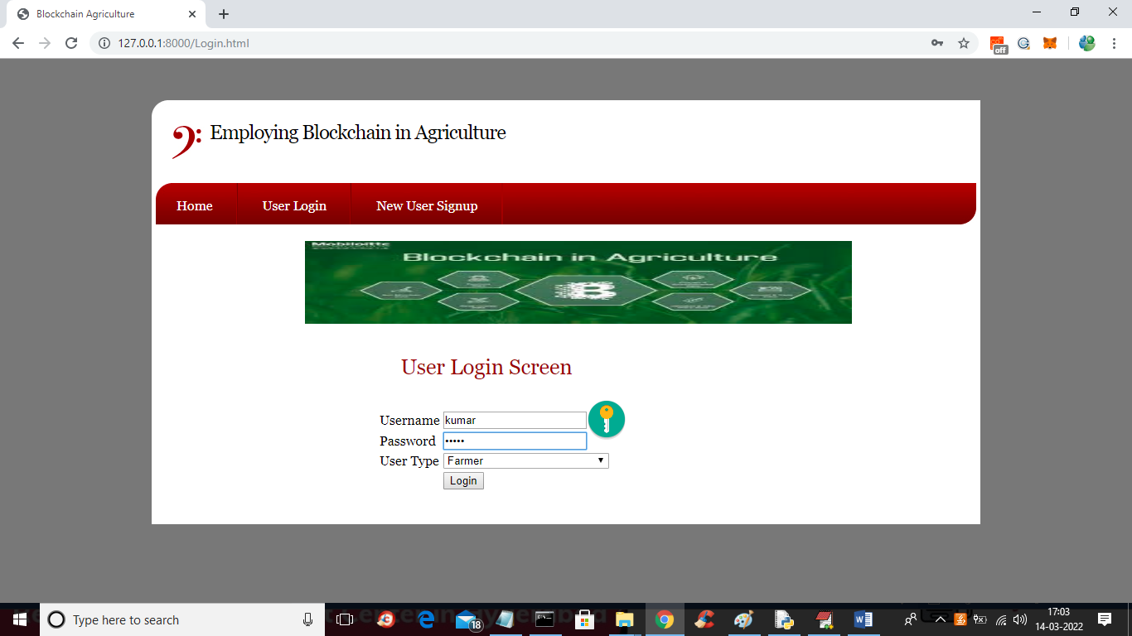
In above screen kumar farmer user is login and after login will get below screen
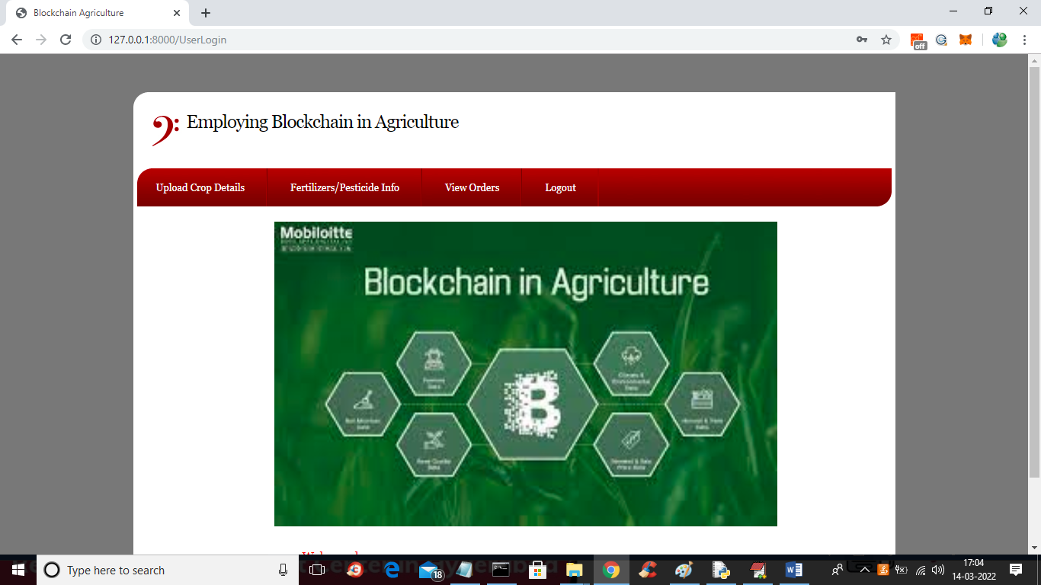
In above screen click on ‘Upload Crop Details’ link to upload crop details and get below screen
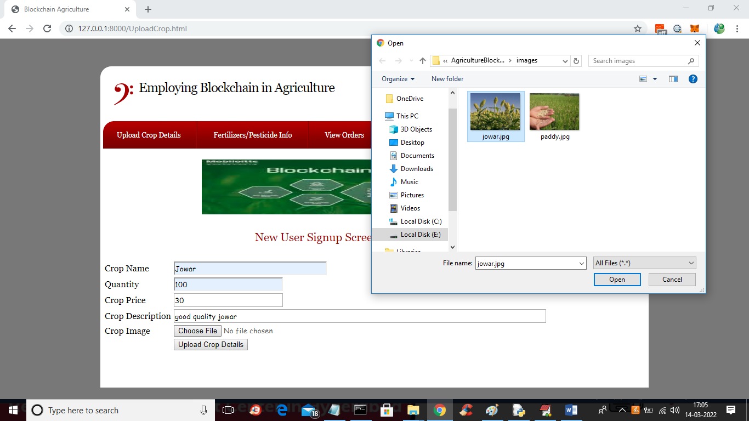
In above screen farmer is uploading crop details with images and then click on ‘Upload Crop Details’ button to get below output
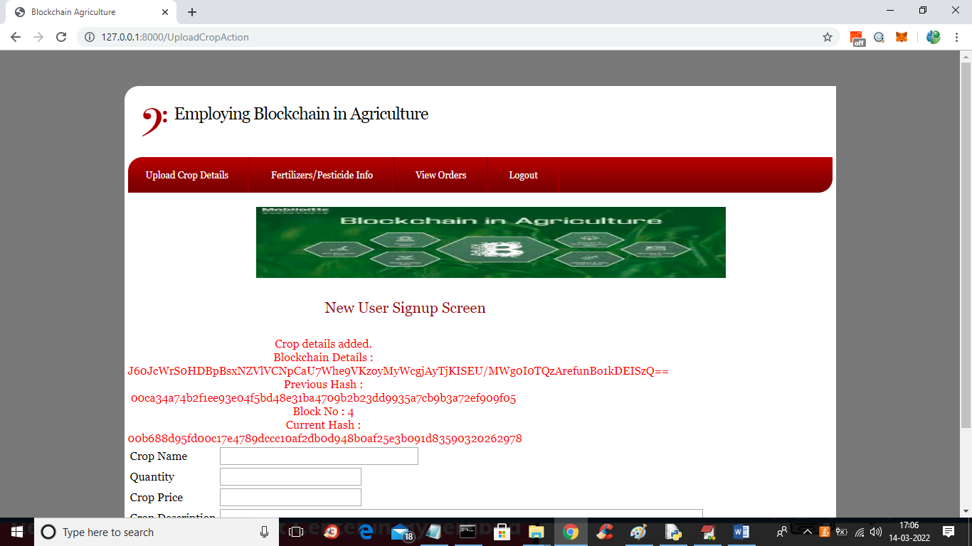
In above screen crop details added in Blockchain and we can see hash code of old and new block. Similarly you can add any number of crops and now click on ‘Fertilizers/Pesticide Info’ link to view fertilizers details
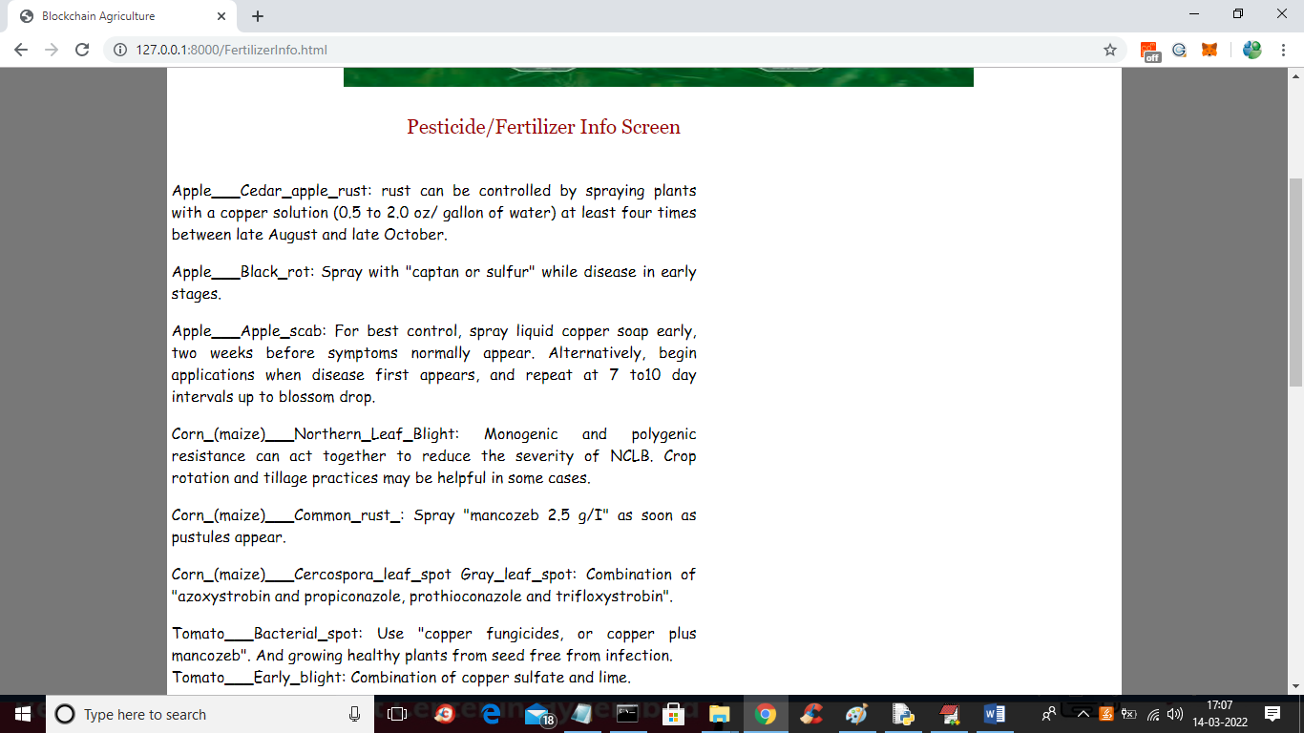
In above screen farmer can view crop names and the require fertilizers and now logout and login as other users to purchase crops
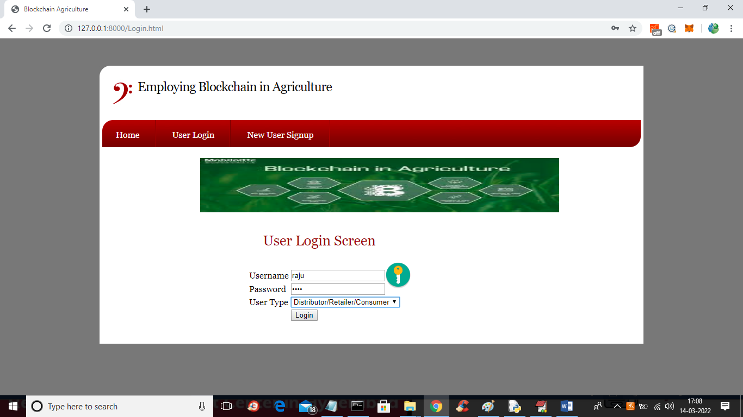
In above screen distributor user is login and after login will get below screen
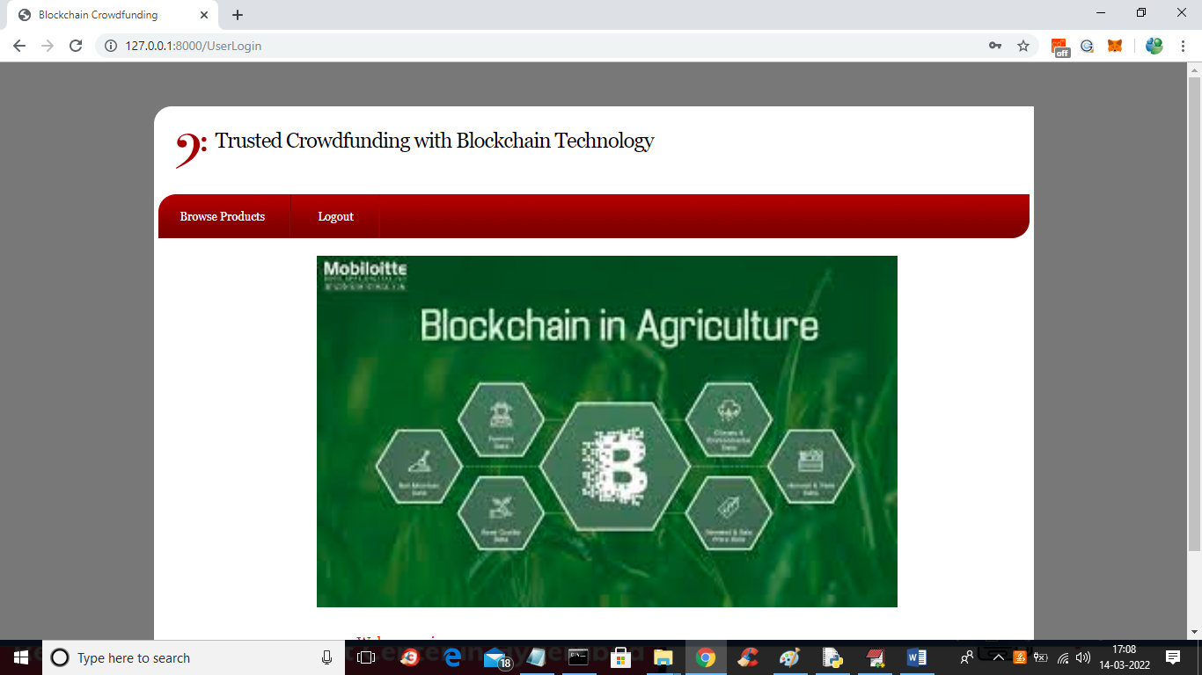
In above screen click on ‘Browse Products’ link to get products details
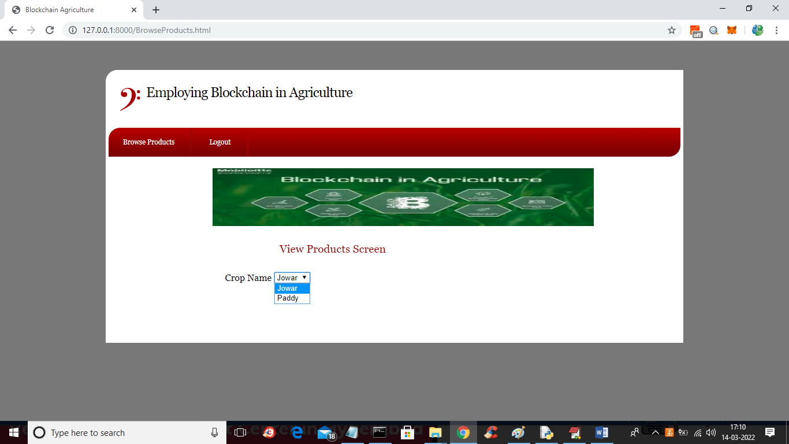
In above screen distributor user can select desire crop and then click button to get below output
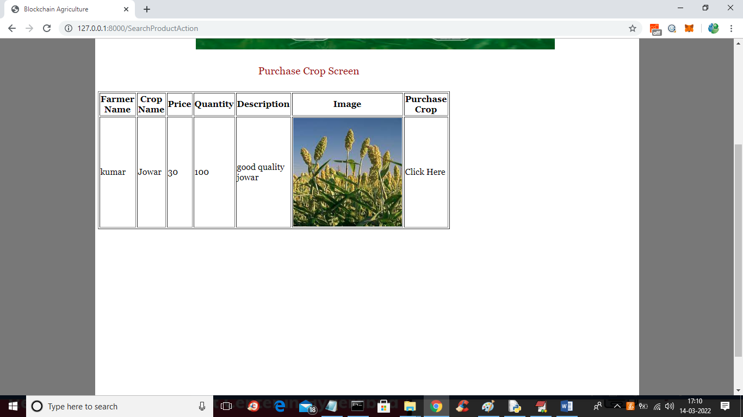
In above screen distributor can view all details and then click on ‘Click Here’ link to make purchase
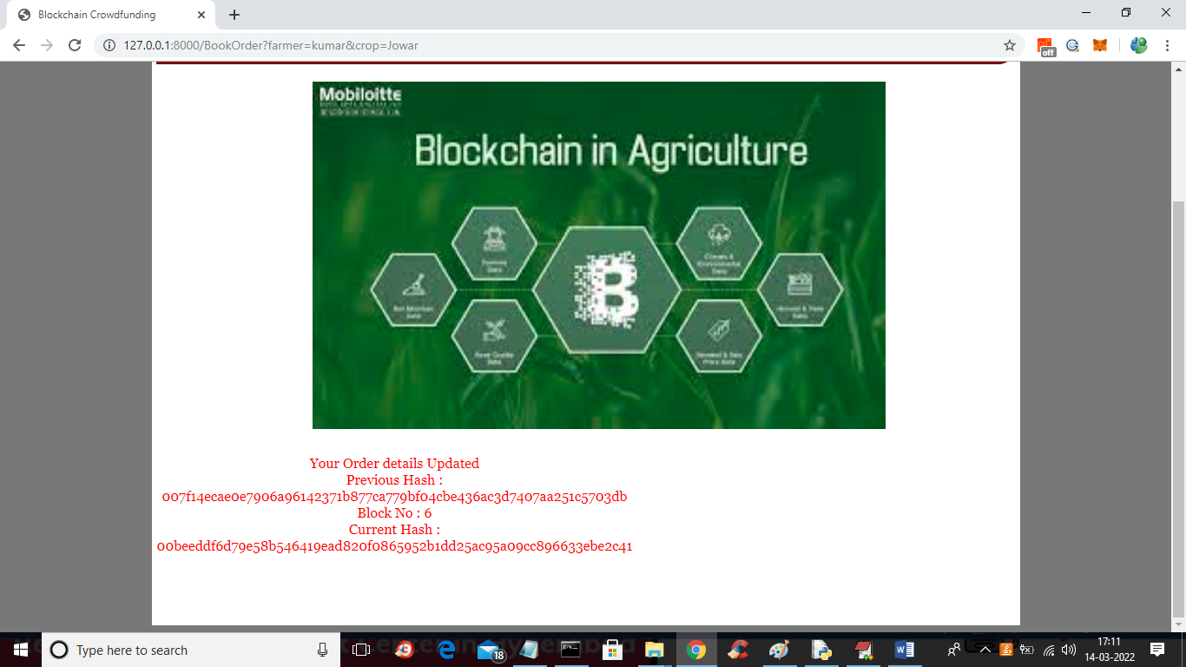
In above screen in red colour text we can see distributor order is confirmed and now logout and login as Miller
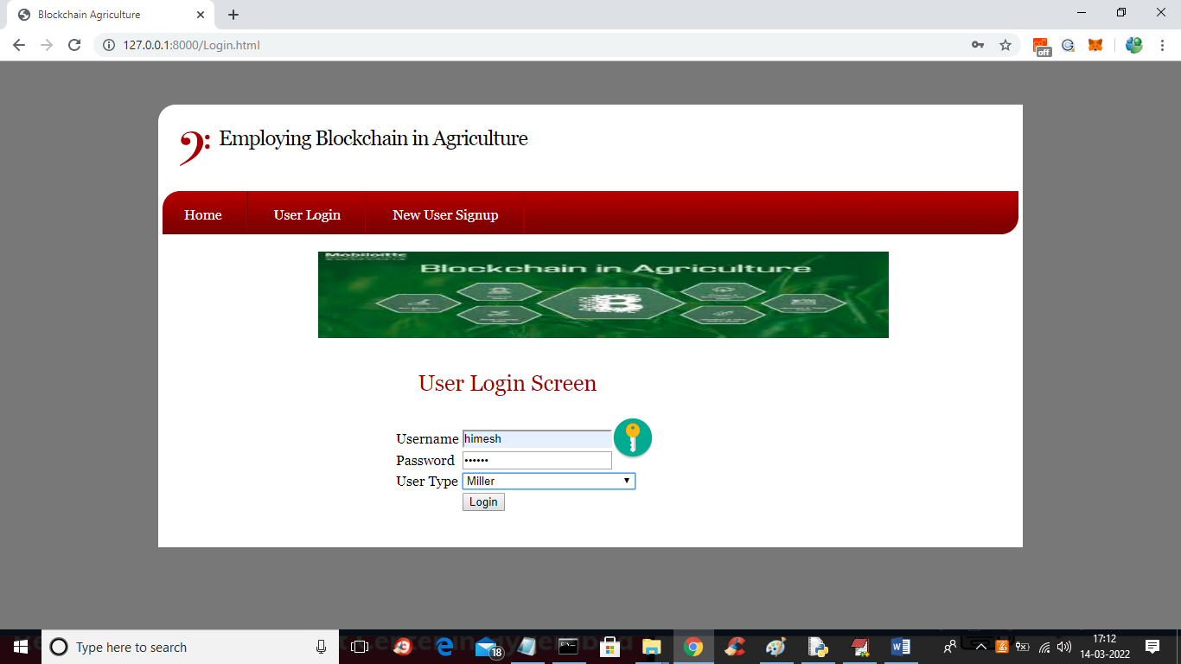
In above screen miller user is login and after login will get below screen
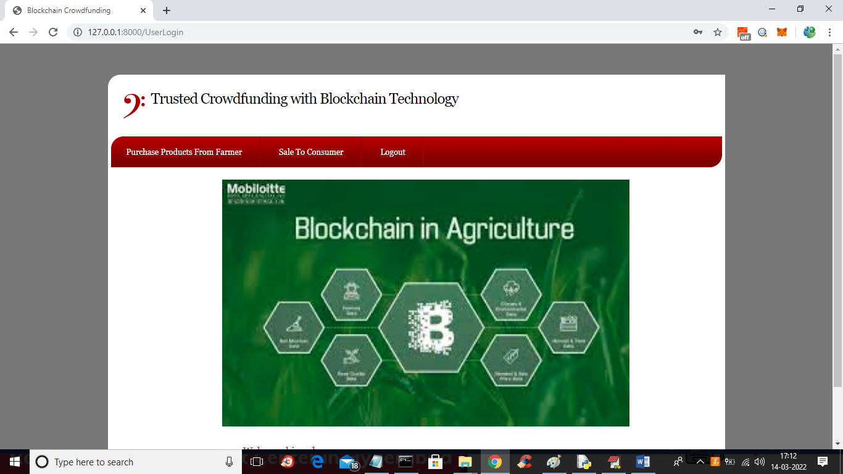
In above screen click on ‘Purchase Products from Farmer’ link to get crop screen
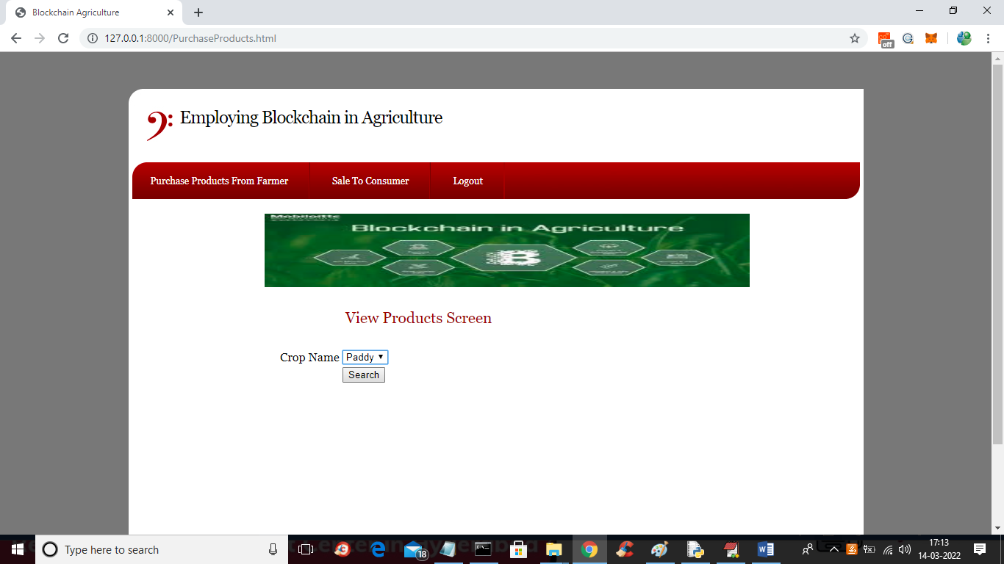
In above screen select the crop and press button to view crop details like below screen
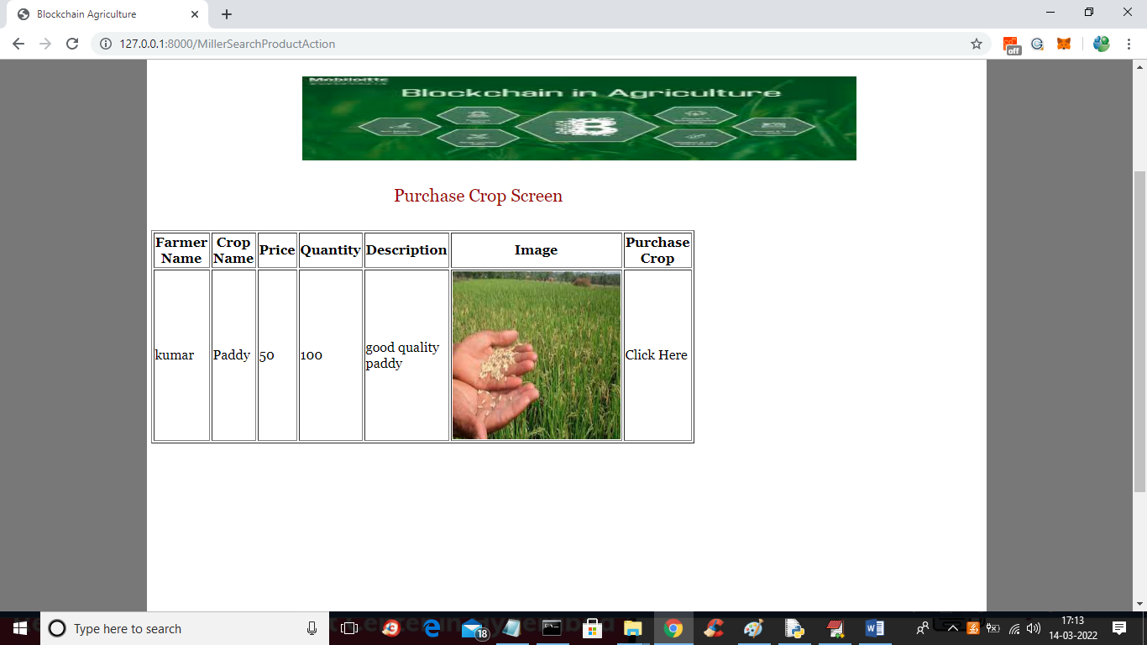
In above screen all crop details can be view by Miller and then click on ‘Click Here’ link to get below purchase screen
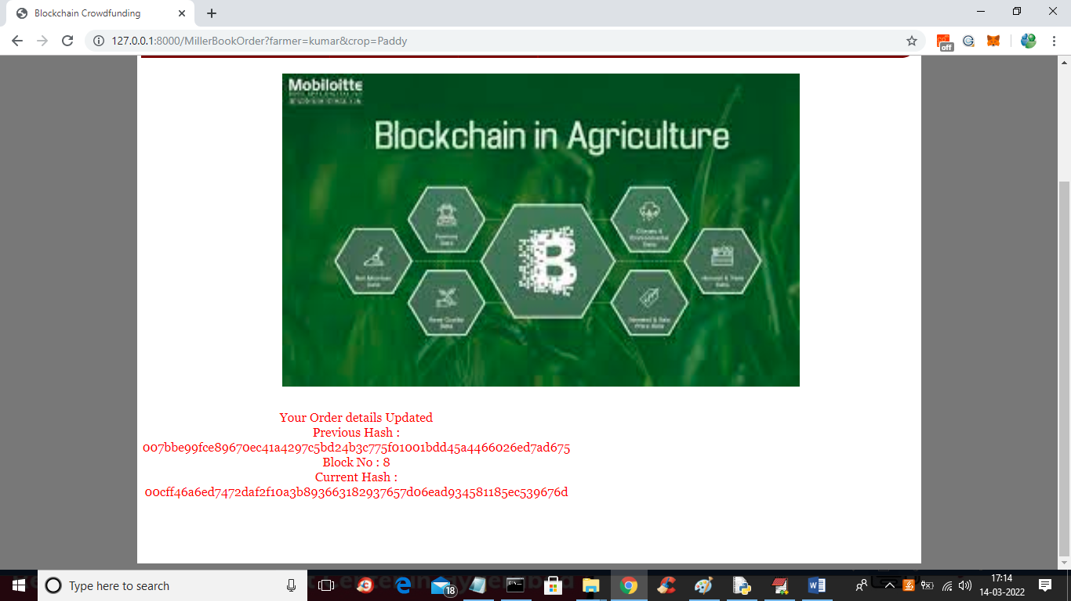
In above screen order details updated and this order will be view and fulfilled by farmer and now click on ‘Sale To Consumer’ link to get below screen
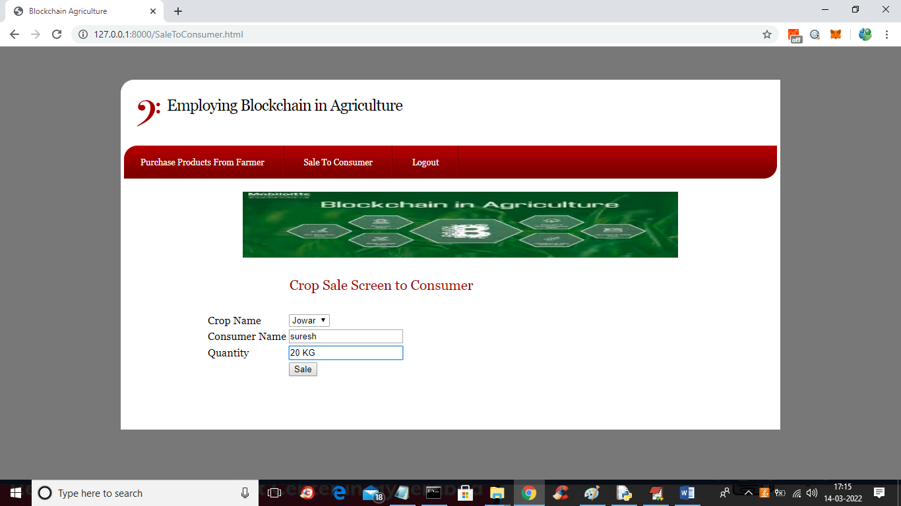
In above screen Miller will sale crop to consumer and press button to get below output
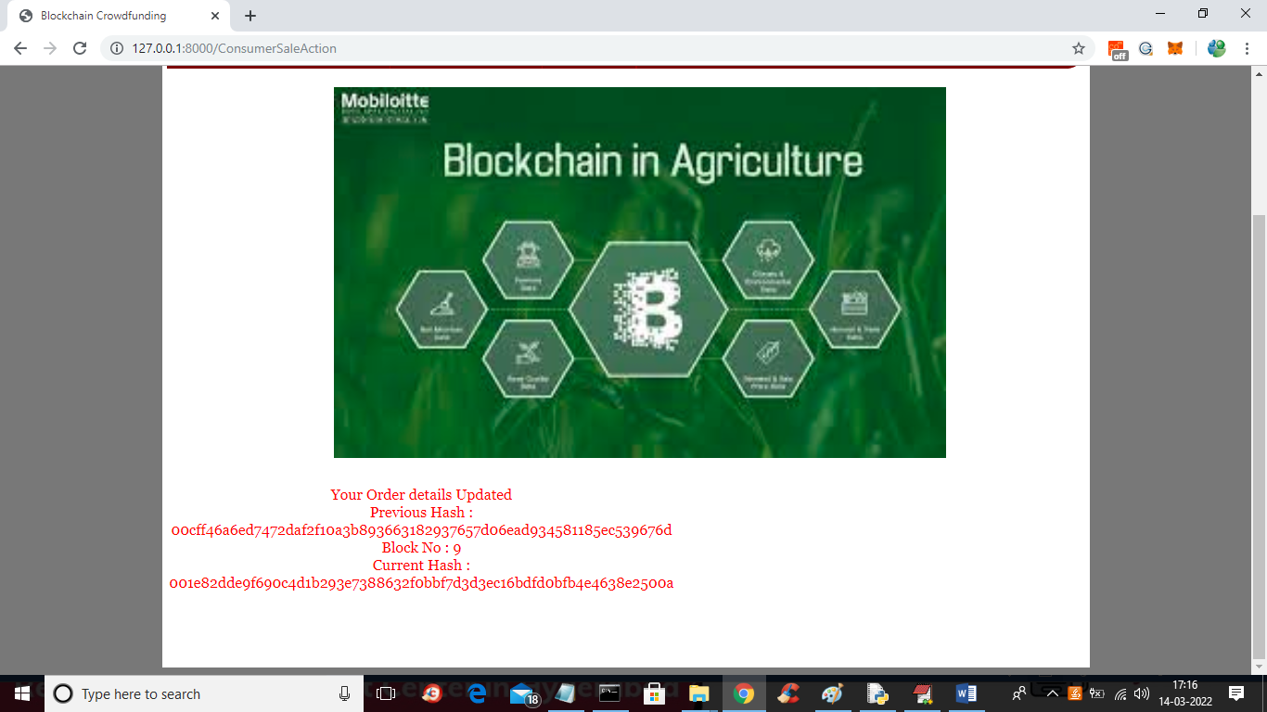
In above screen sale to consumer order is updated and now logout and login as farmer to view orders like below screen
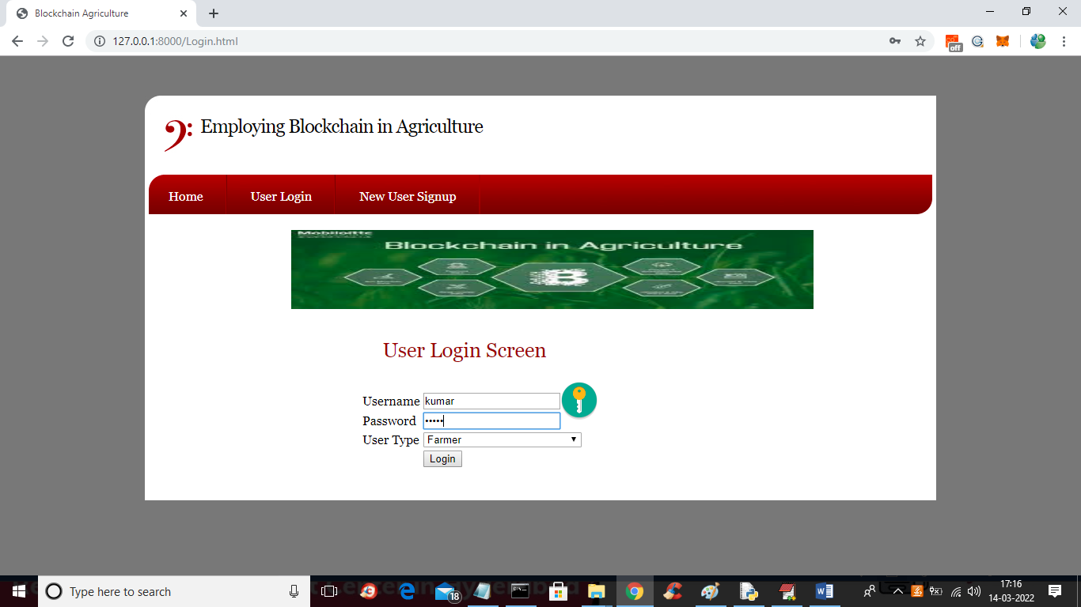
In above screen farmer is login and after login will get below output
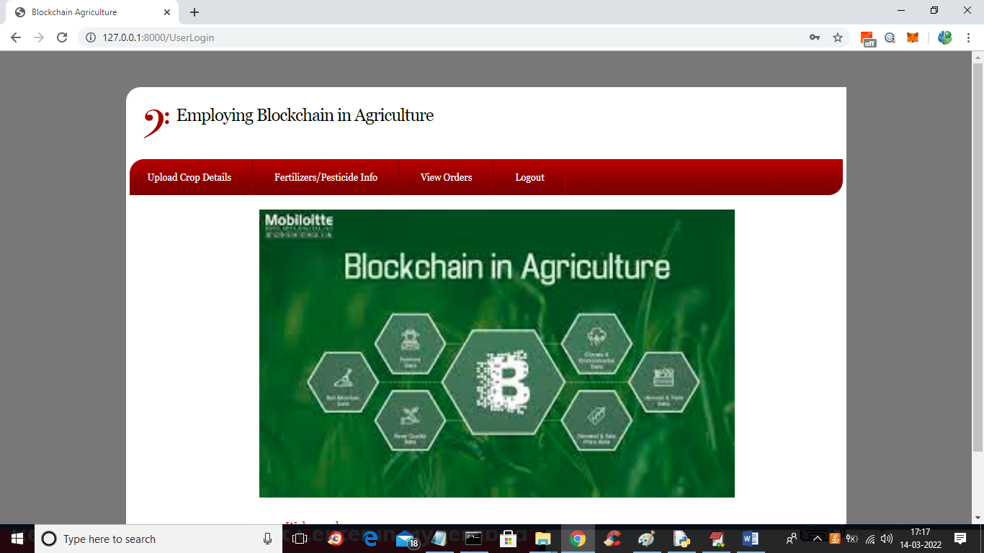
In above screen click on ‘View Orders’ link to get below orders details
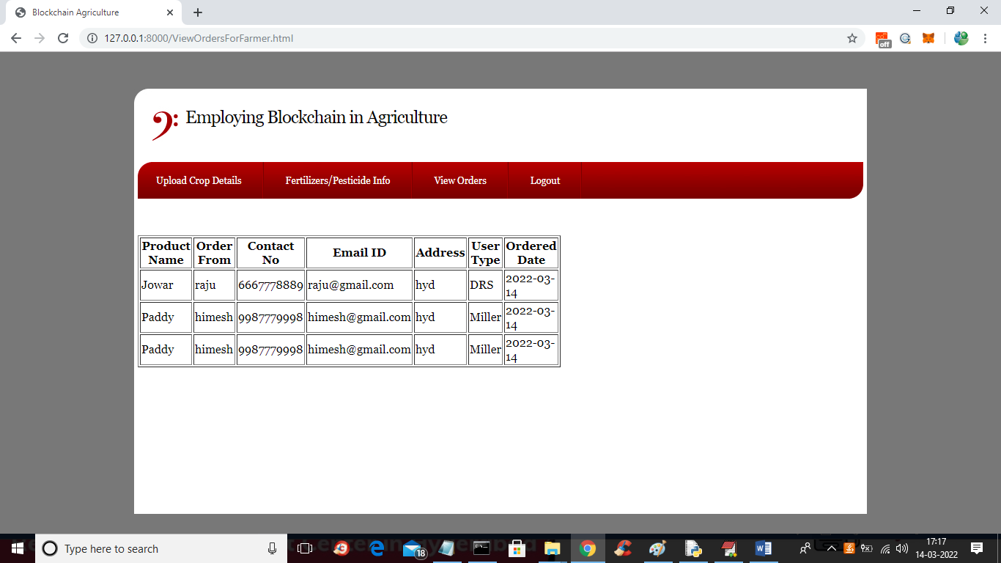
In above screen farmer can view details of purchaser like crop name, quantity and their contact details with user type as DRS (distributor/ retailer/ consumer) or Miller and then complete the order

